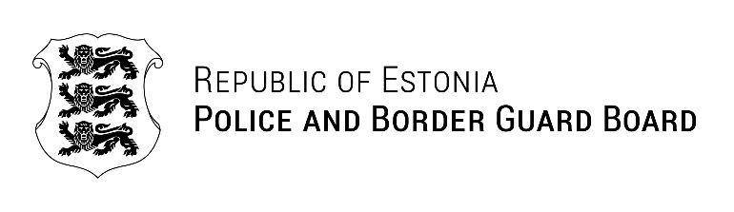
Our ref .01.2025 no 1.5-2/
BSRBCC Secretariat Meeting Invitation
Dear members of the BSRBCC Secretariat,

As the Estonian Police and Border Guard Board is chairing the BSRBCC in 2025, it is my pleasure to invite you to the BSRBCC Secretariat meeting organised in Tallinn, Estonia on 12 February 2025. The purpose of the meeting is to discuss the outcomes of the BSRBCC Heads meeting 2024 and the planned activities for our BSRBCC 2025 presidency. Please find the draft agenda of the meeting attached to the letter.
The meeting will take place at the Estonian Police and Border Guard Board headquarters (Pärnu mnt 139, Tallinn, 15060).
Up to 2 participants from Finland, Latvia and Frontex are invited to attend the meeting. The Estonian Police and Border Guard Board will cover the accommodation costs and provide for dinner, lunch and coffee break during the meeting.
Please find attached to this invitation:
- The meeting’s draft agenda
- The meeting’s registration form
- Practical information concerning the meeting
We kindly ask you to submit the completed registration form to BSRBCC2025@politsei.ee by 30 January, 2025.
We look forward to welcoming you in Tallinn!

Yours sincerely

Eve Kalmus
Police Colonel
Head of Border Management Bureau

